**Observation 30- body package**

**Create employee table:**

CREATE TABLE emplos (

emp_id NUMBER PRIMARY KEY,

salary NUMBER

);

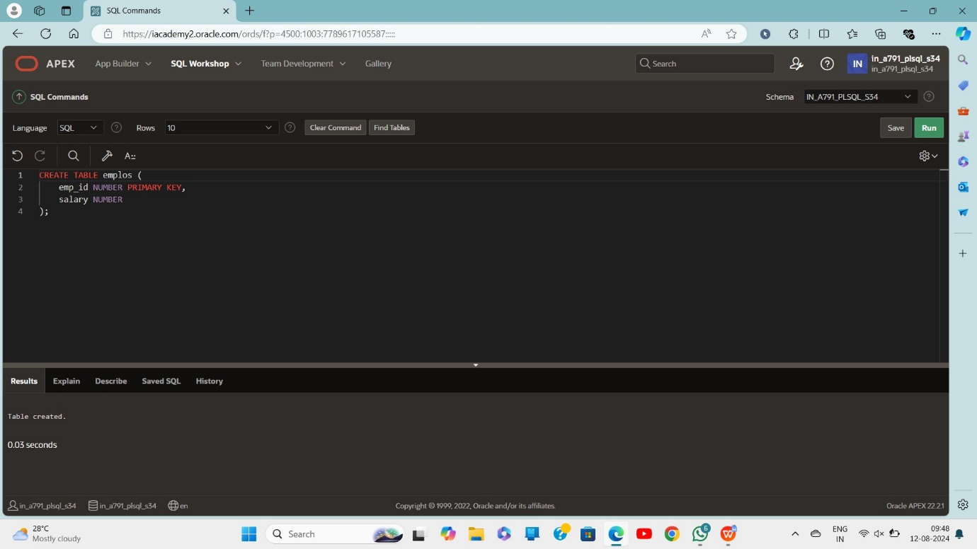

**insert values:**

INSERT INTO employees (emp_id, salary)

VALUES (101, 30000);

INSERT INTO employees (emp_id, salary)

VALUES (102, 35000);

INSERT INTO employees (emp_id, salary)

VALUES (103, 28000);

INSERT INTO employees (emp_id, salary)

VALUES (100, 24000);

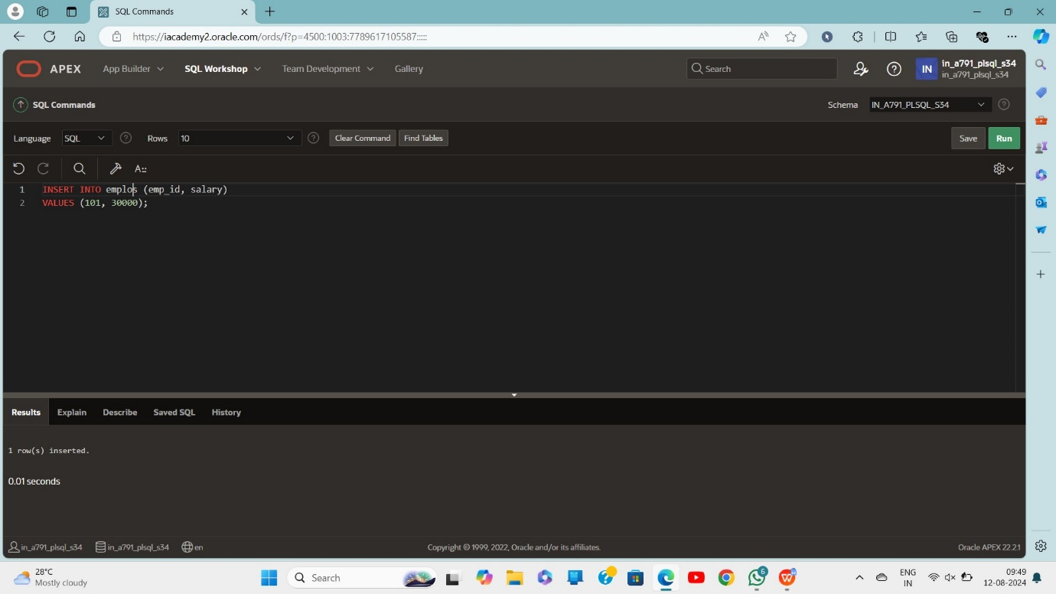

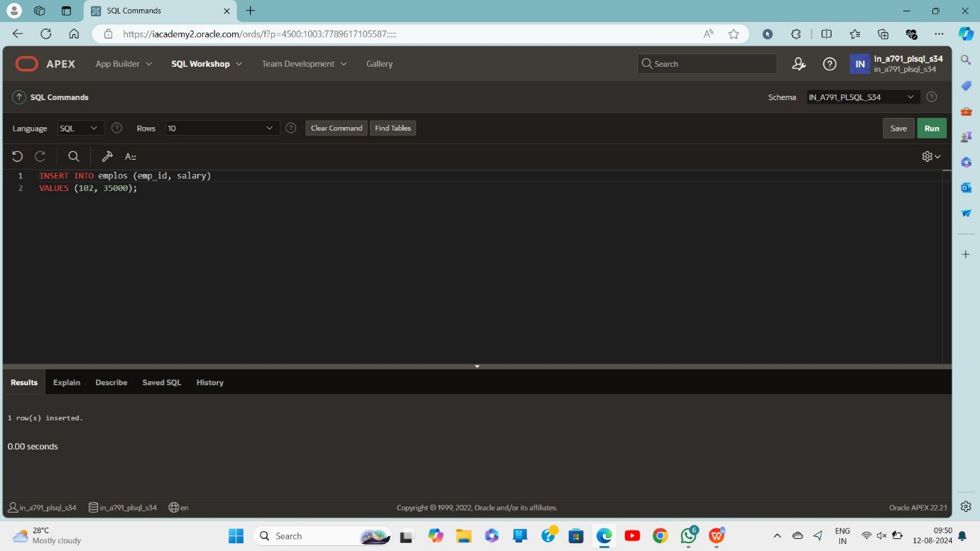

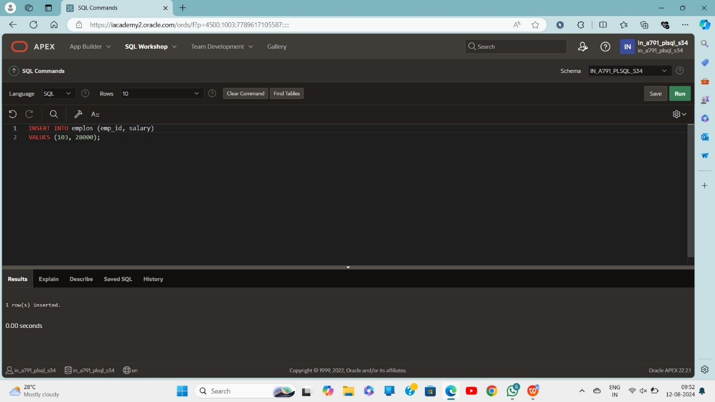

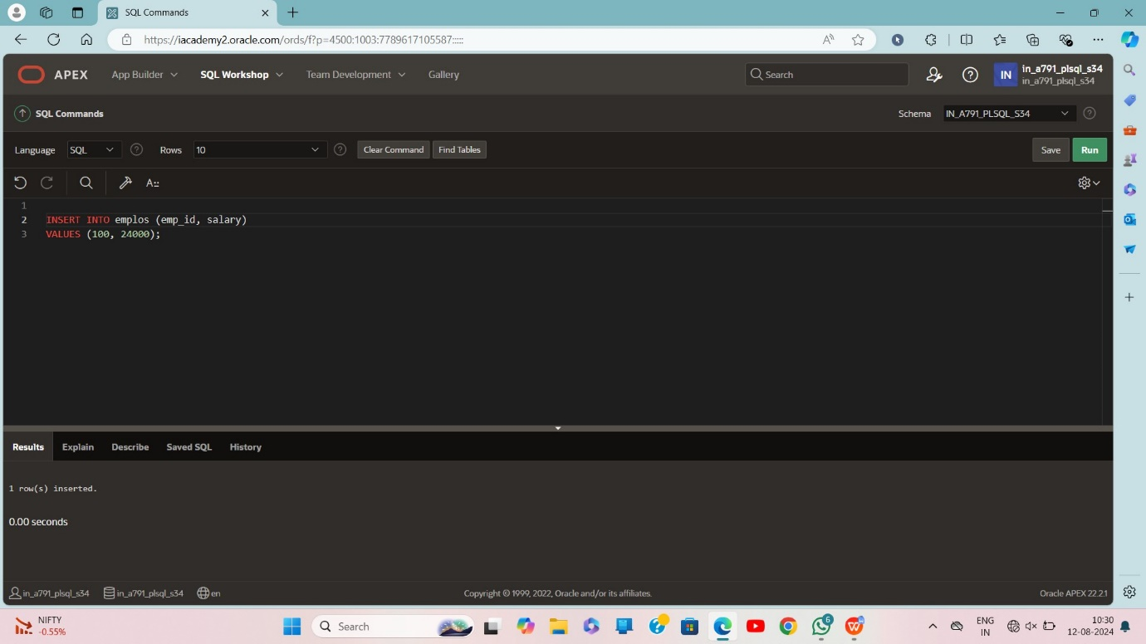

Select*from emplos

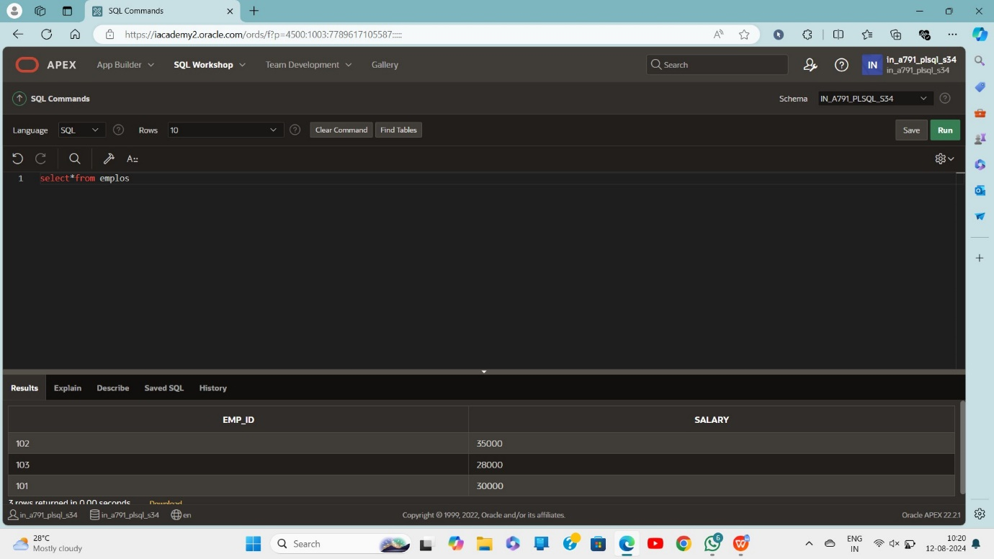

**Create package:**

CREATE OR REPLACE PACKAGE salary_pkg IS

g_max_sal_raise NUMBER := 10000;

v_old_salary NUMBER;

PROCEDURE update_sal(p_emp_id NUMBER, p_new_salary NUMBER);

FUNCTION validate_raise(p_old_salary NUMBER, p_new_salary NUMBER) RETURN BOOLEAN;

END salary_pkg;

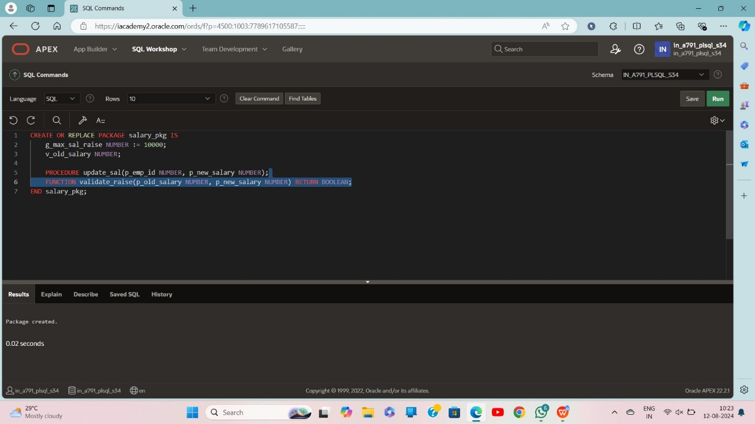

CREATE OR REPLACE PACKAGE BODY salary_pkg IS

PROCEDURE update_sal(p_emp_id NUMBER, p_new_salary NUMBER) IS

BEGIN

SELECT salary INTO v_old_salary FROM emplos WHERE emp_id = p_emp_id;

UPDATE emplos

SET salary = p_new_salary

WHERE emp_id = p_emp_id;

END update_sal;

FUNCTION validate_raise(p_old_salary NUMBER, p_new_salary NUMBER) RETURN BOOLEAN IS

BEGIN

IF (p_new_salary - p_old_salary) <= g_max_sal_raise THEN

RETURN TRUE;

ELSE

RETURN FALSE;

END IF;

END validate_raise;

END salary_pkg;

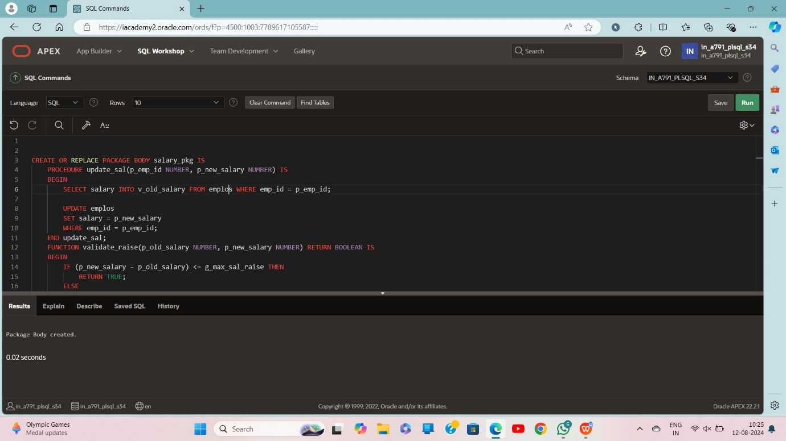

**Declare:**

DECLARE

v_bool BOOLEAN;

v_number NUMBER;

BEGIN

salary_pkg.update_sal(100, 25000);

v_bool := salary_pkg.validate_raise(24000, 25000);

v_number := salary_pkg.g_max_sal_raise;

v_number := salary_pkg.v_old_salary;

END;

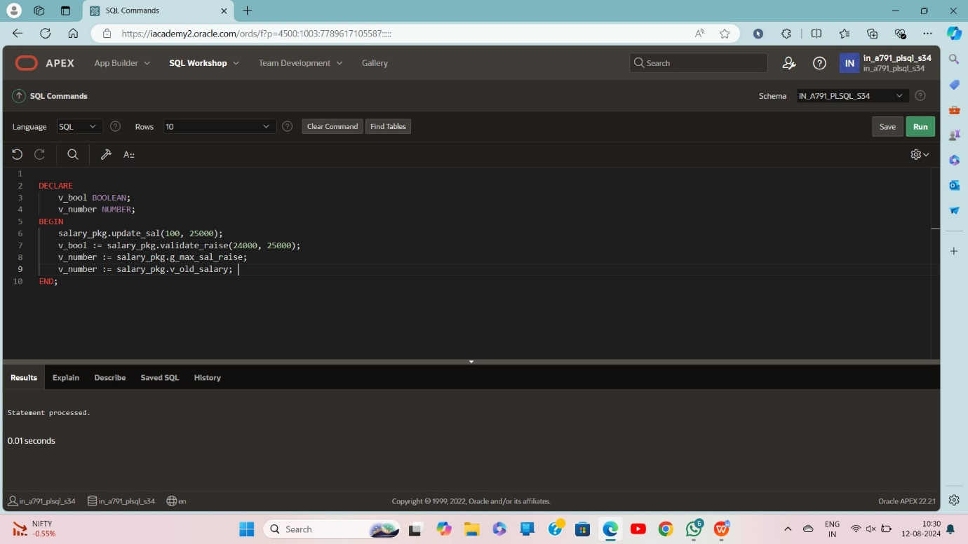

Select*from emplos

